Application Load Balancer to Jenkins 06/07/23

Step 1: Navigate to **Load Balancer** in EC2 AWS Console and click on a **Create load balancer.**

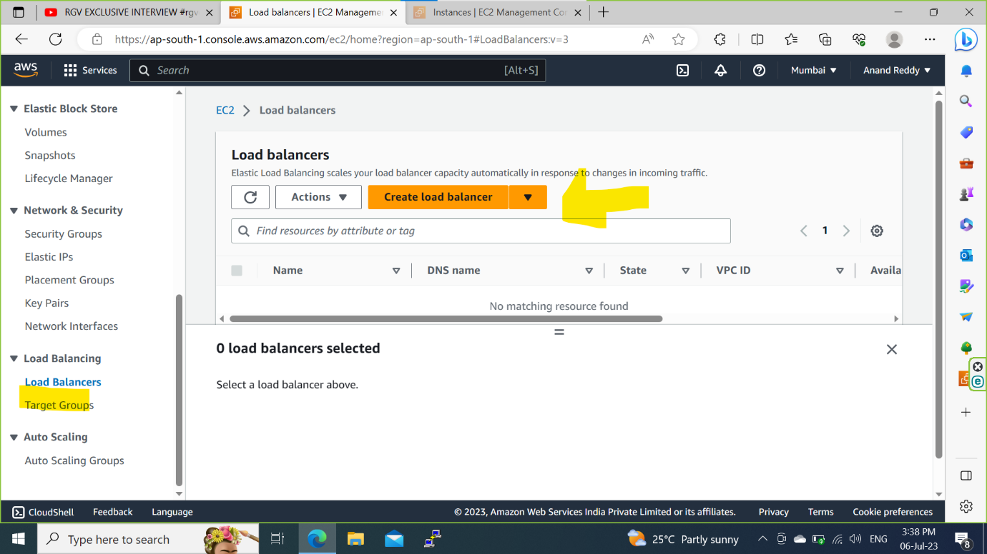

Step 2: Select **Application Load Balancer** and click on **Create.**

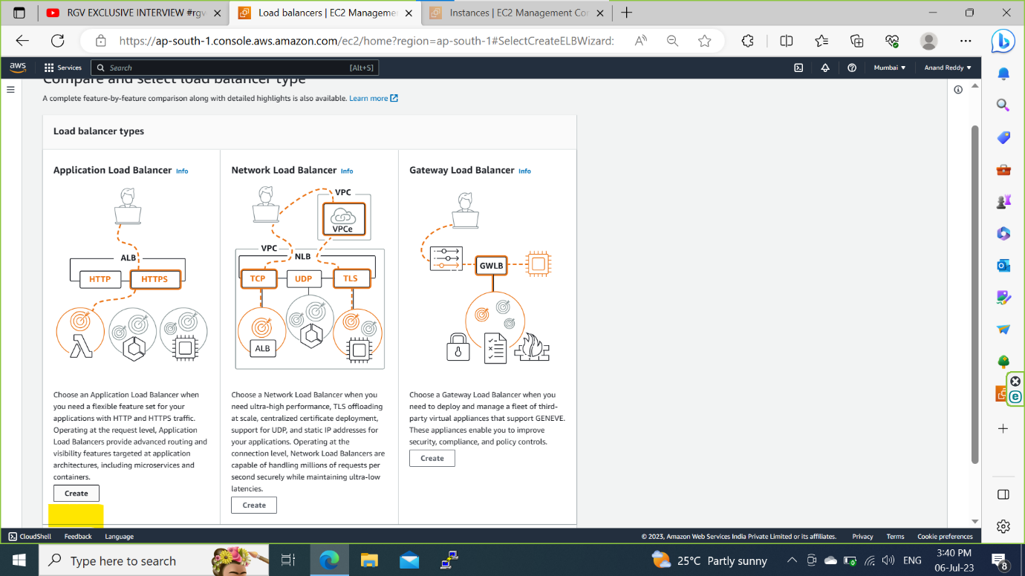

Step 3: Give the **Load balancer name** and check on **Internet-facing** for allowing the public traffic.

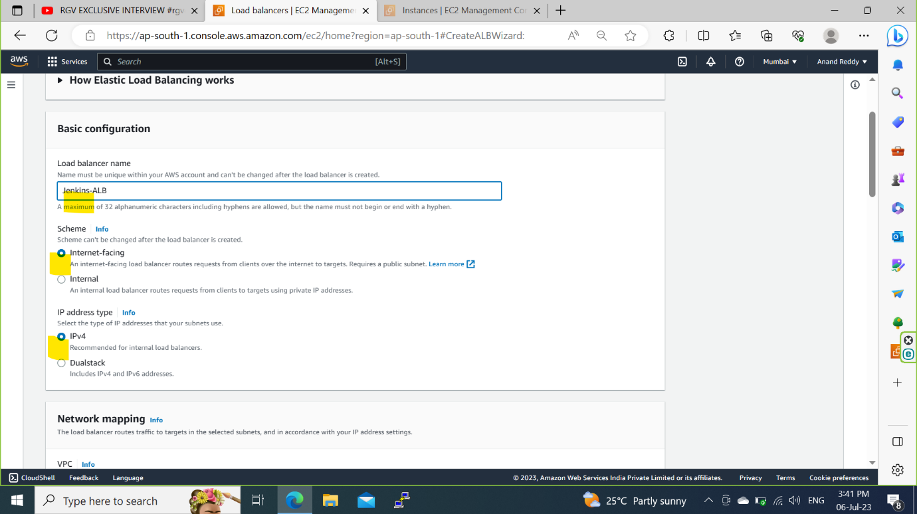

Step 3a: In **Network Mapping** select default or custom **VPC** and check on to all the Availibility Zone for high availibity.

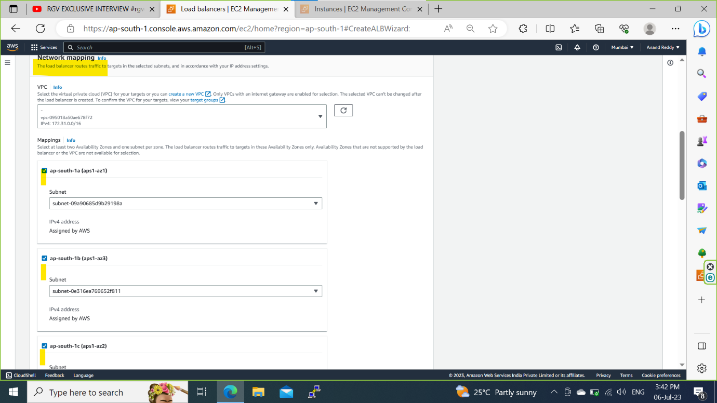

Step 3b: Select the default or custom **Security Groups** and click on **Create target group.**

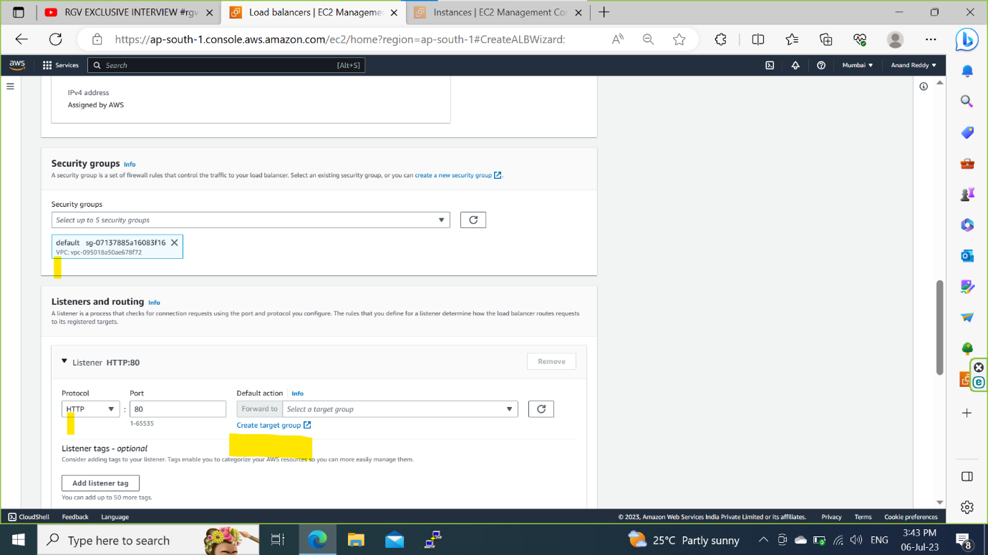

Step 3c: Select the **Instance** and give **Target group name** as **Jenkins-ALB-TG** and Jenkins **Port** number which is **8080.**

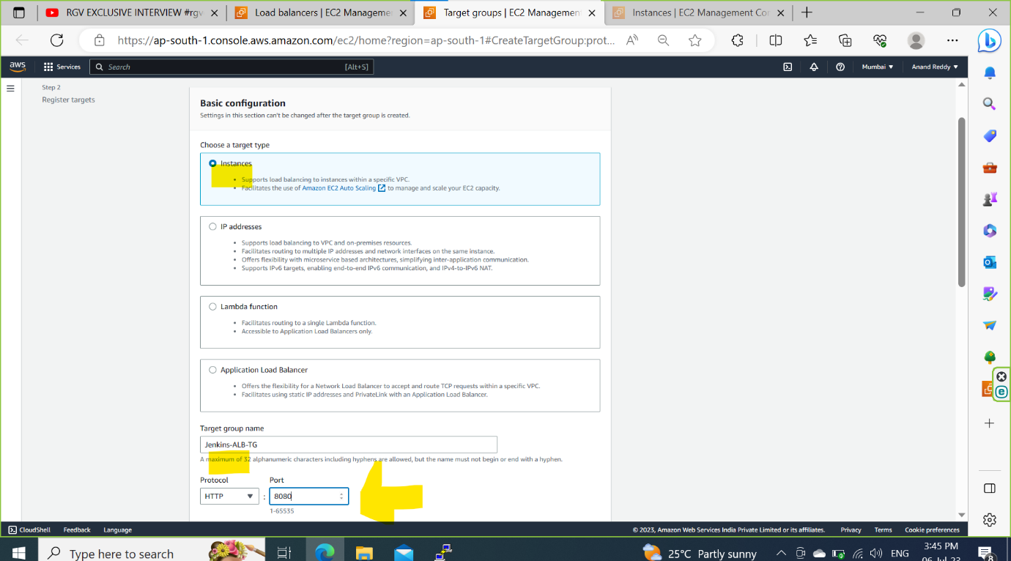

Step 3d: select the default **VPC** and in **Health Check path** give the **/login** (which pings the Jenkins login page based on health configuration).

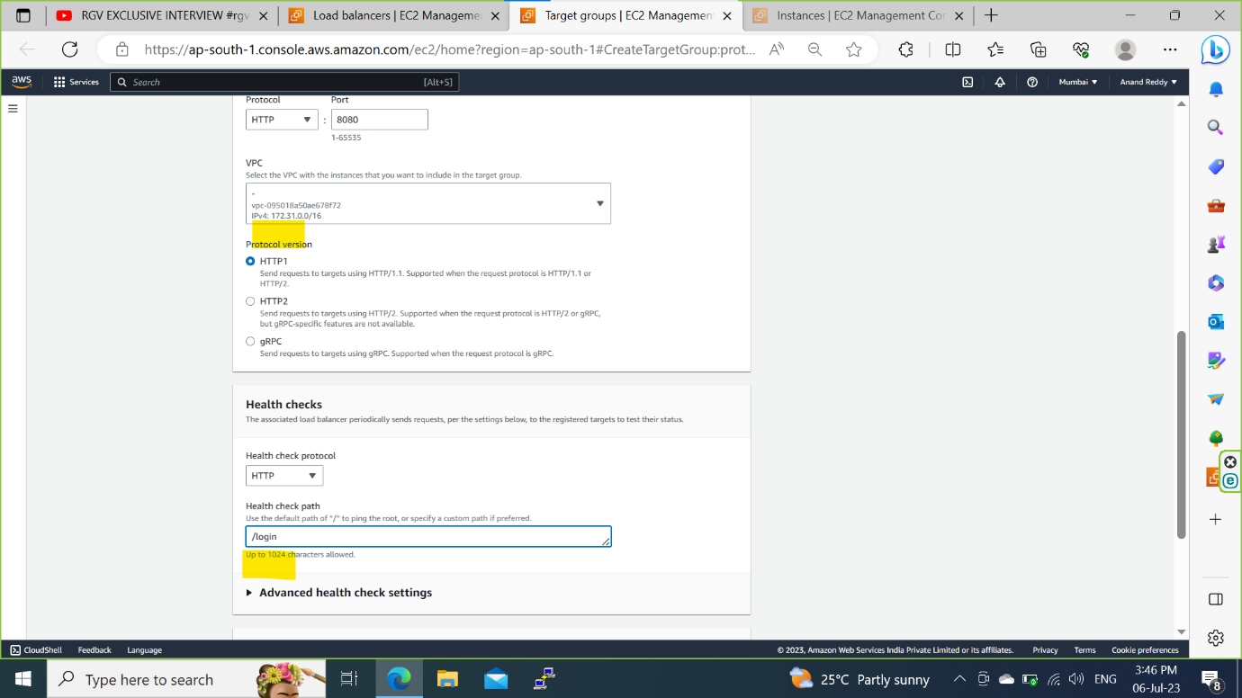

Step 3e: Click on **Advanced health check settings** and configure(optional) or let it be default.

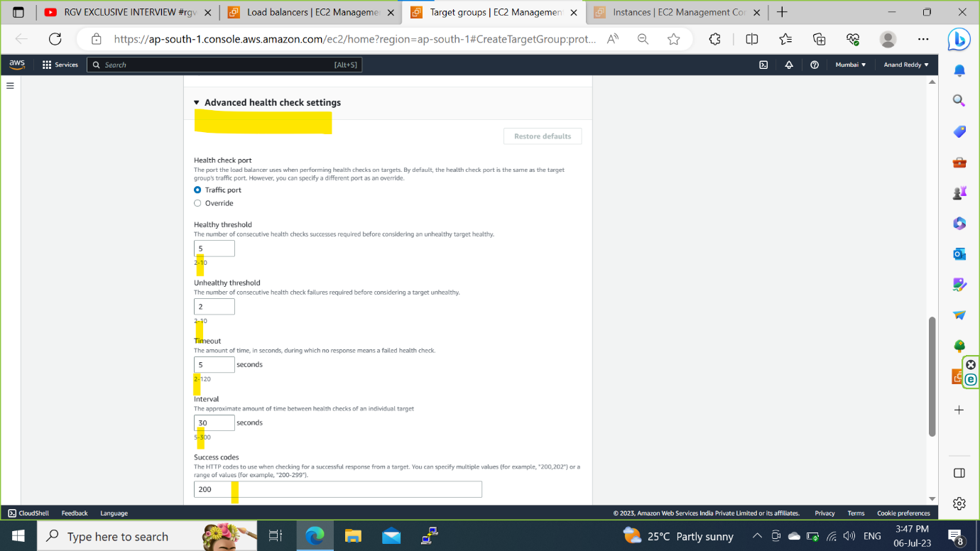

Step 4: Select the instance and click on the **Include as pending below** and click on **Create target group.**

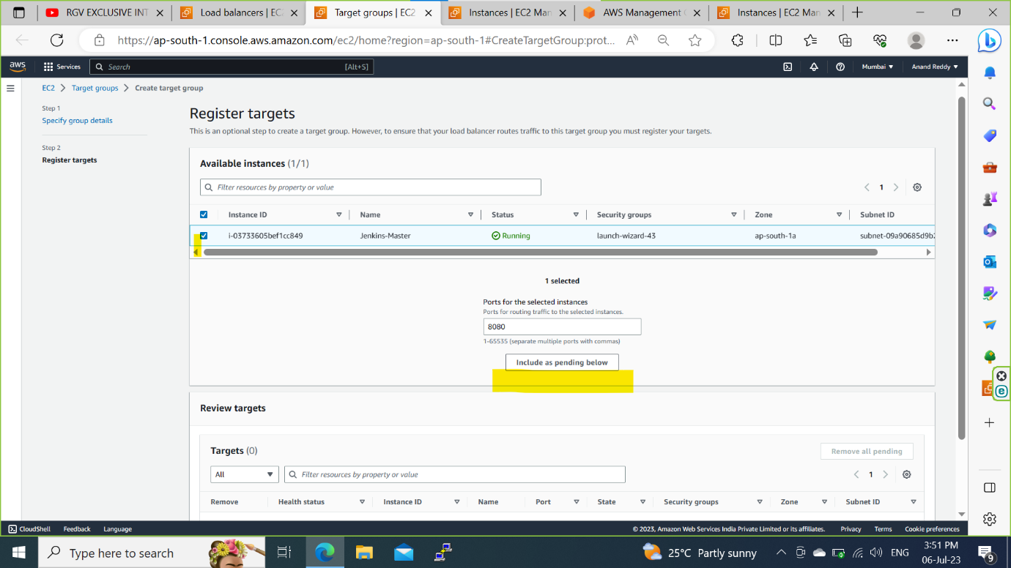

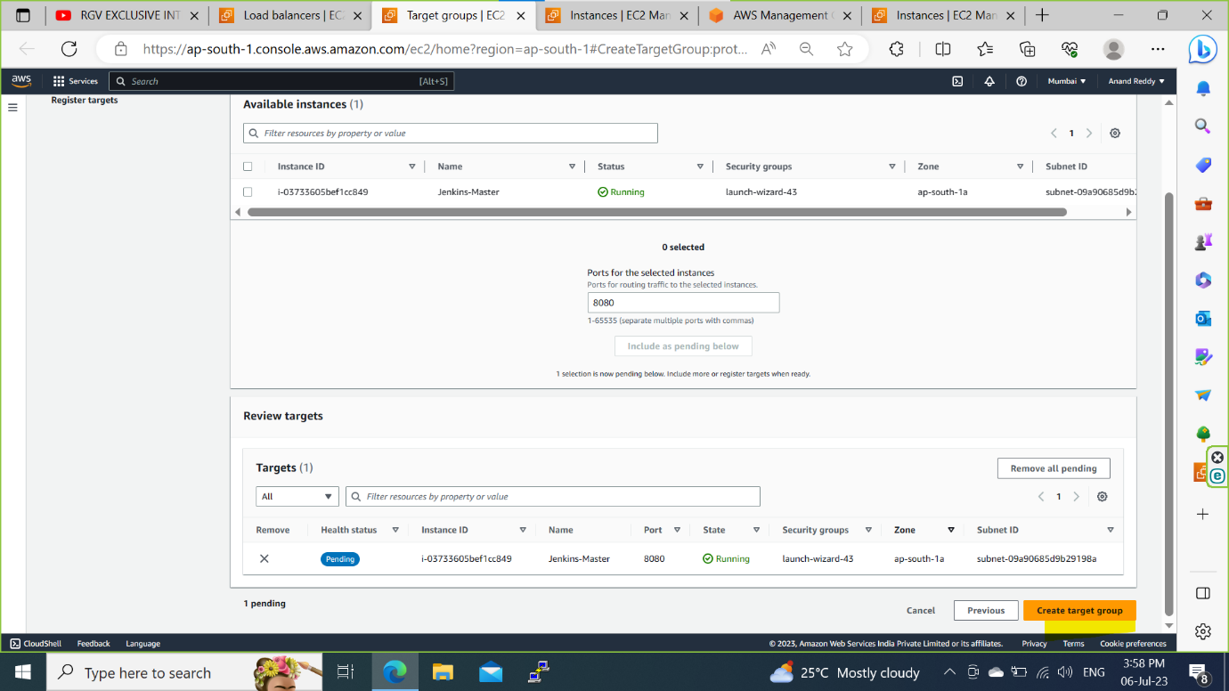

Step 5: Once **Target group Is created** go to **load balancer page** and drop down and select the created target group as **Jenkins-ALB-TG**  for both HTTP and HTTPS by creating a SSL certificate in AWS cerficate manager.

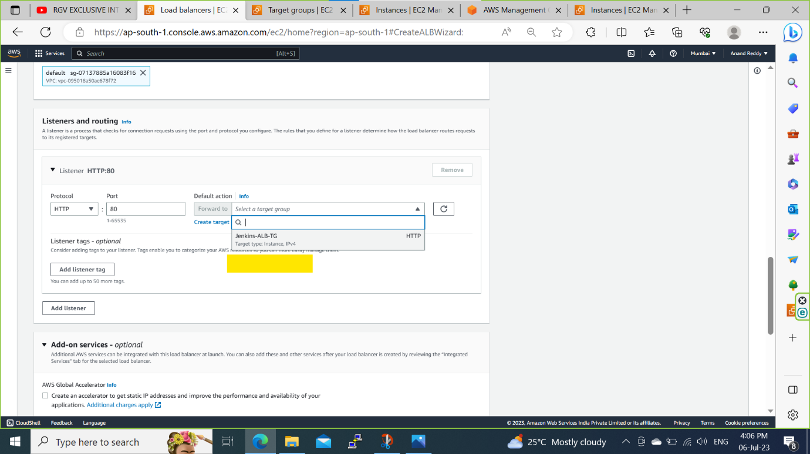

**Steps to create a ACM Certificate:**

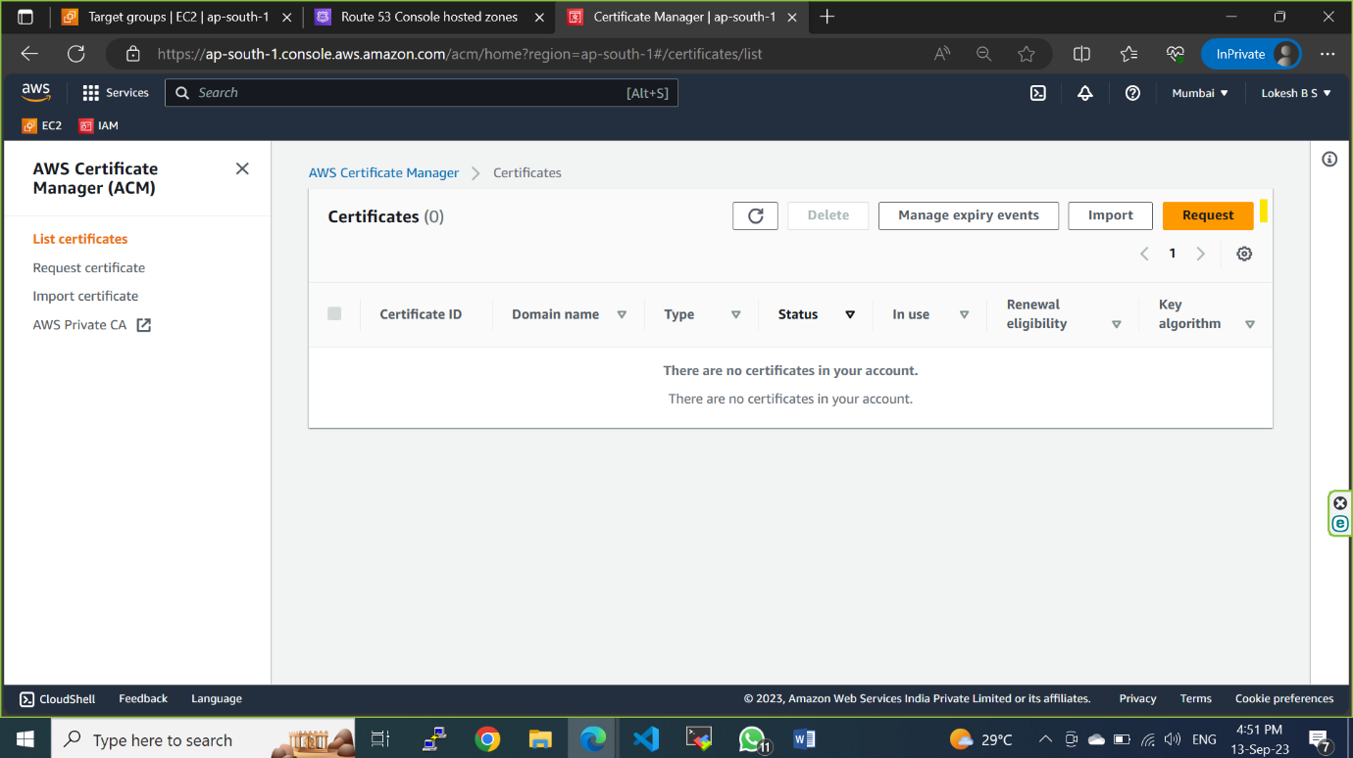

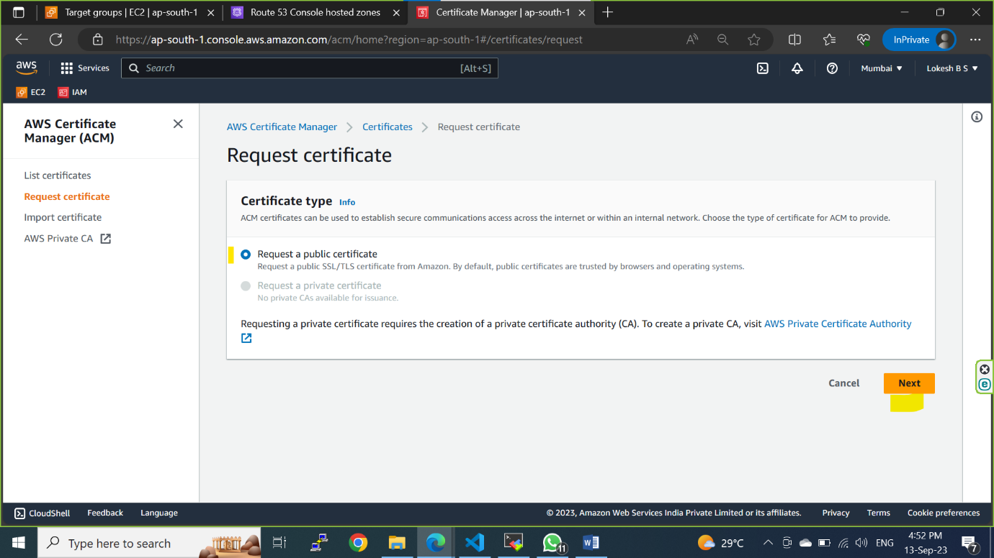

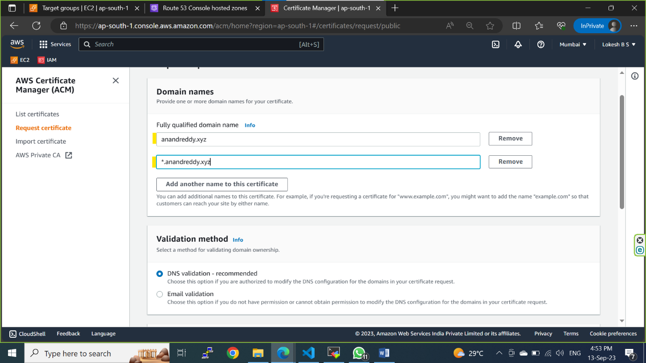

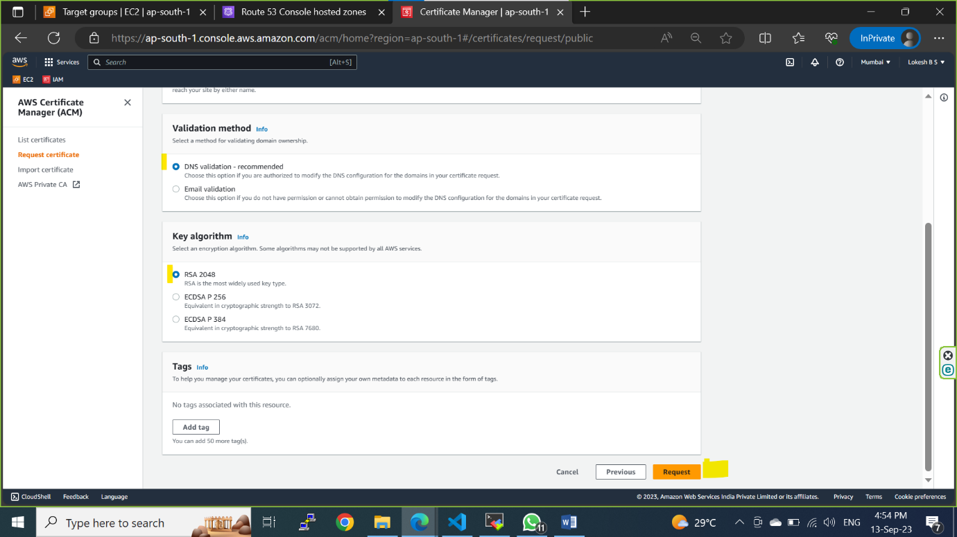

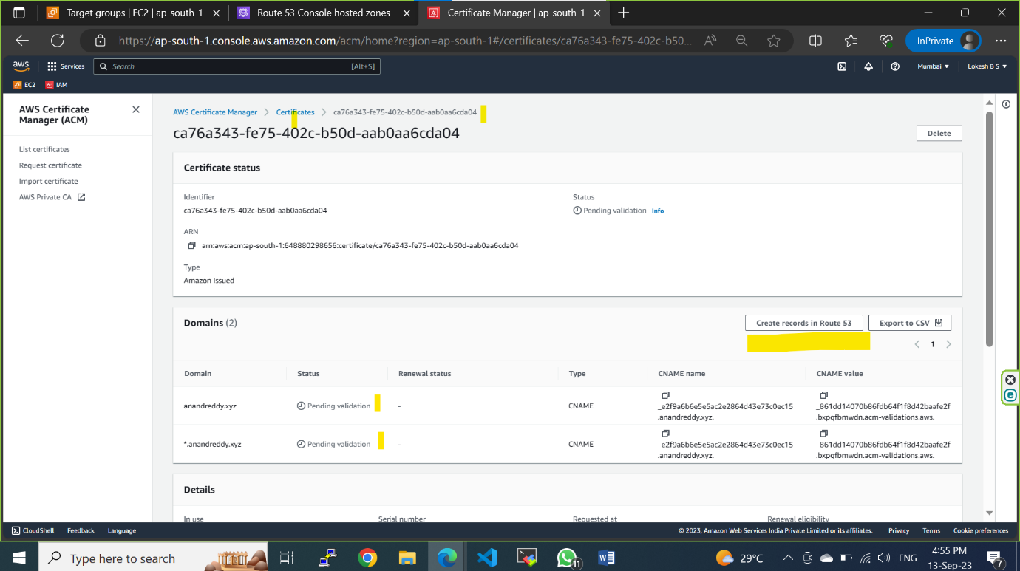

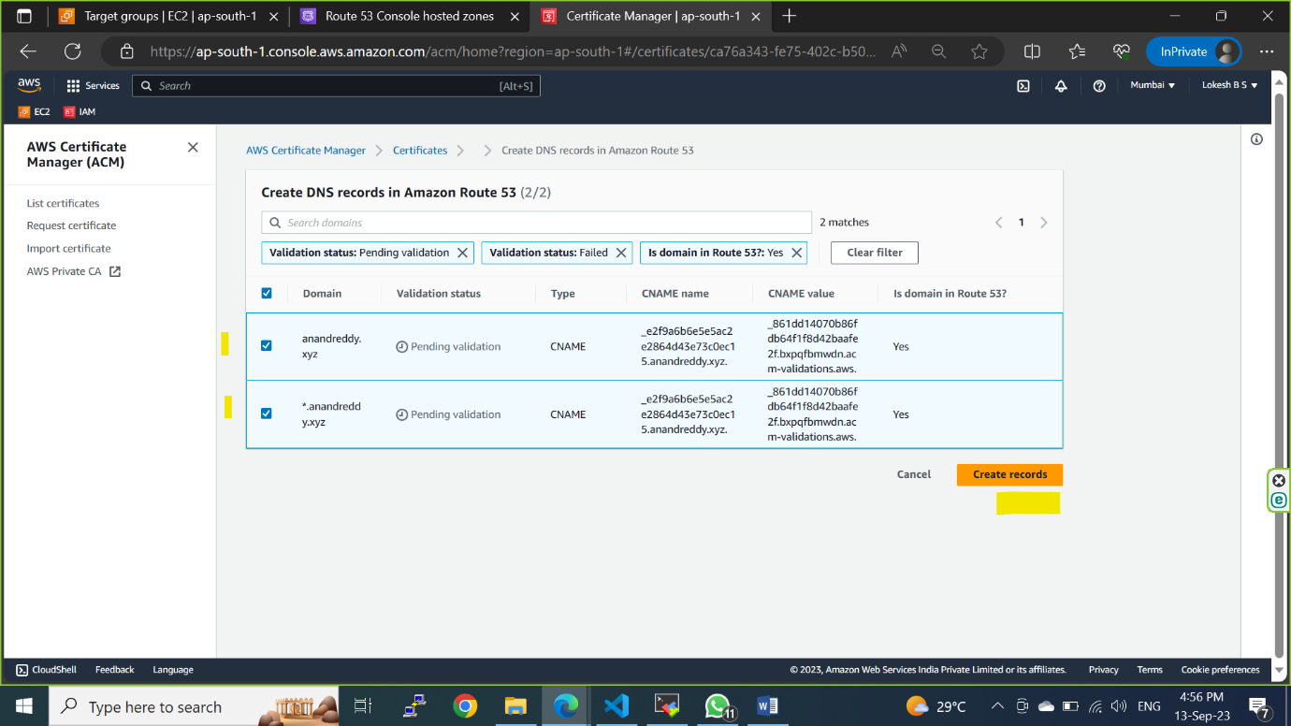

**It will take 2-5mins to issue the certificate**

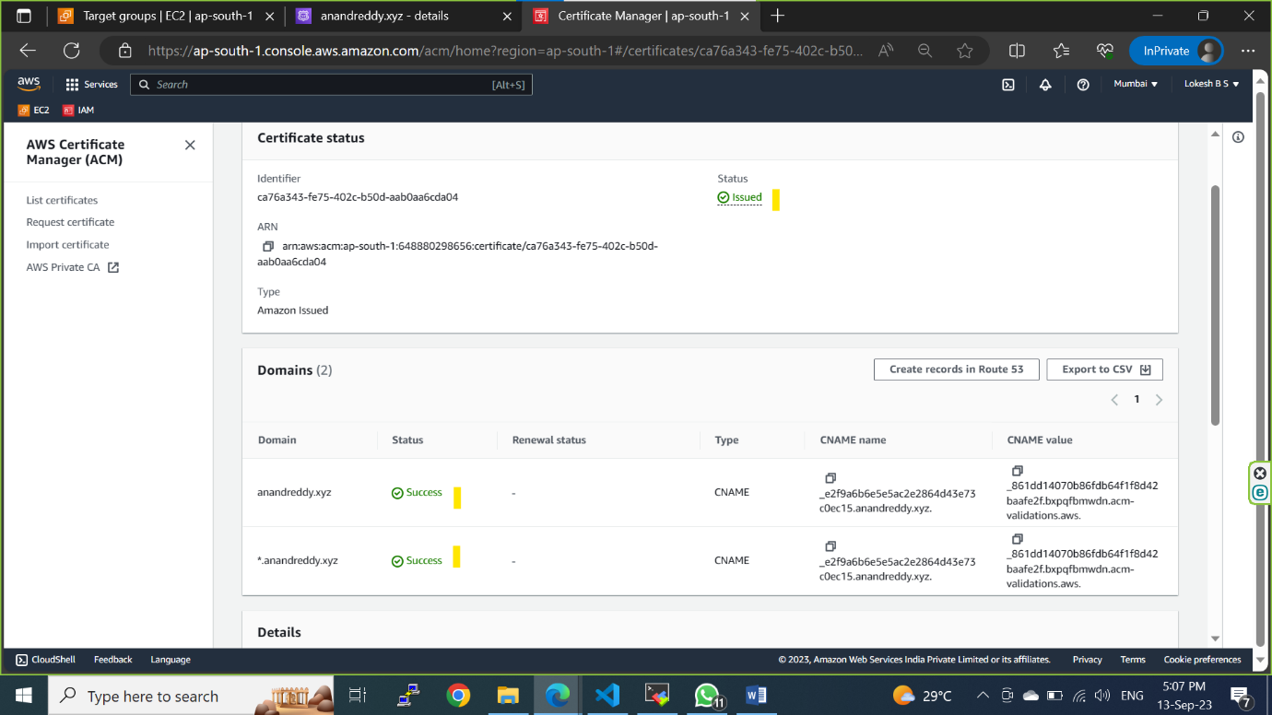

**Attach the created SSL certificate**

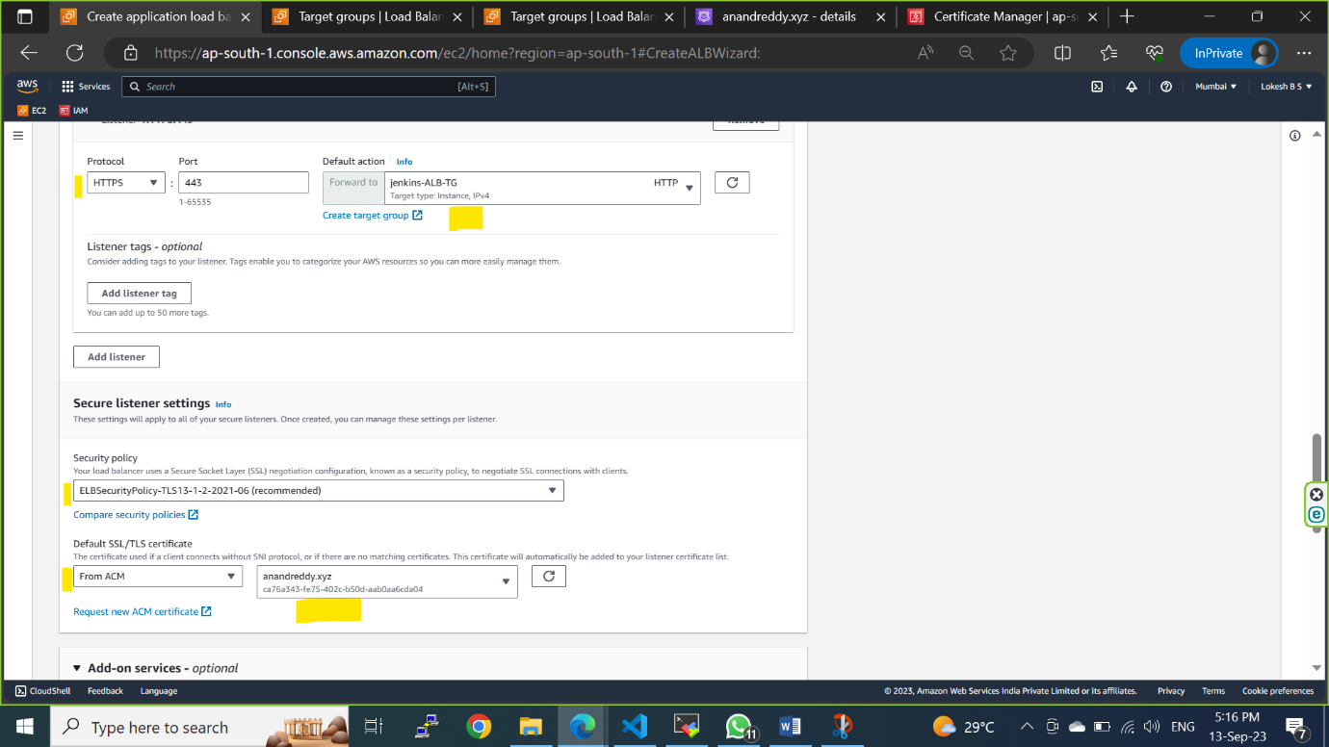

Step 6: Review the configuration summary and click on **Create load balancer.**

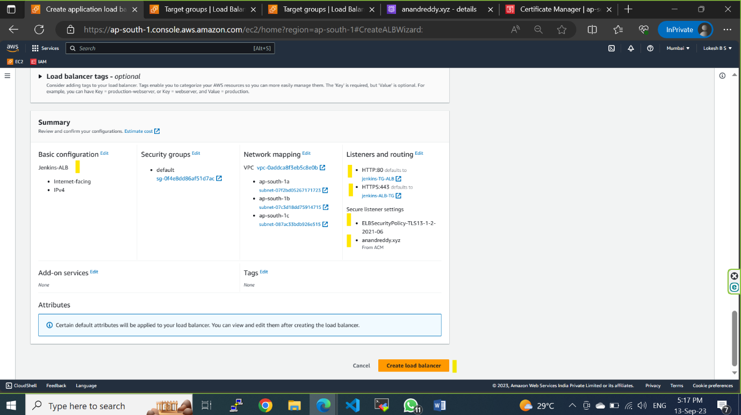

Step 7: Once the load balancer is in **Active** state copy the **DNS name** and redirect http traffic to https.

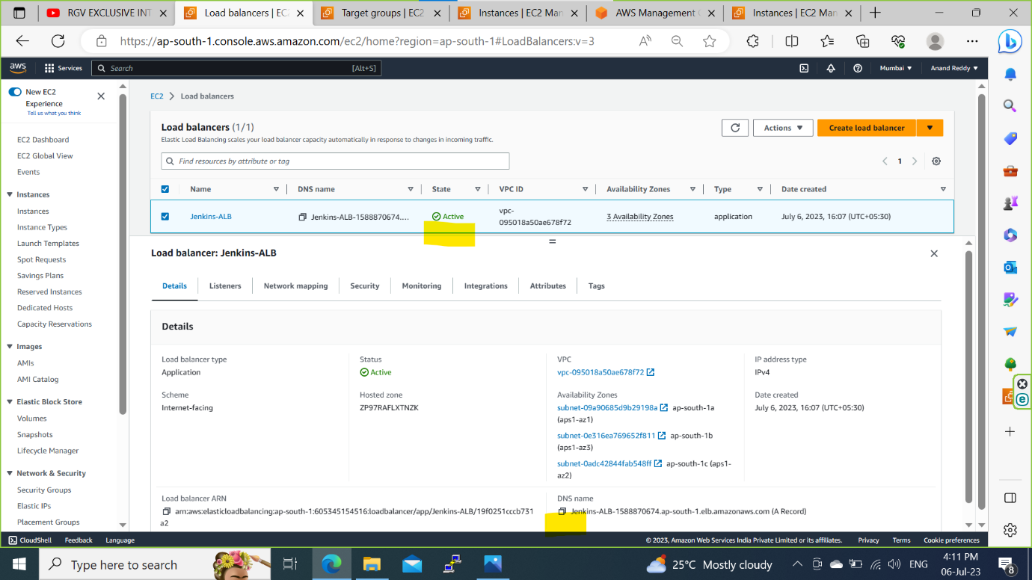

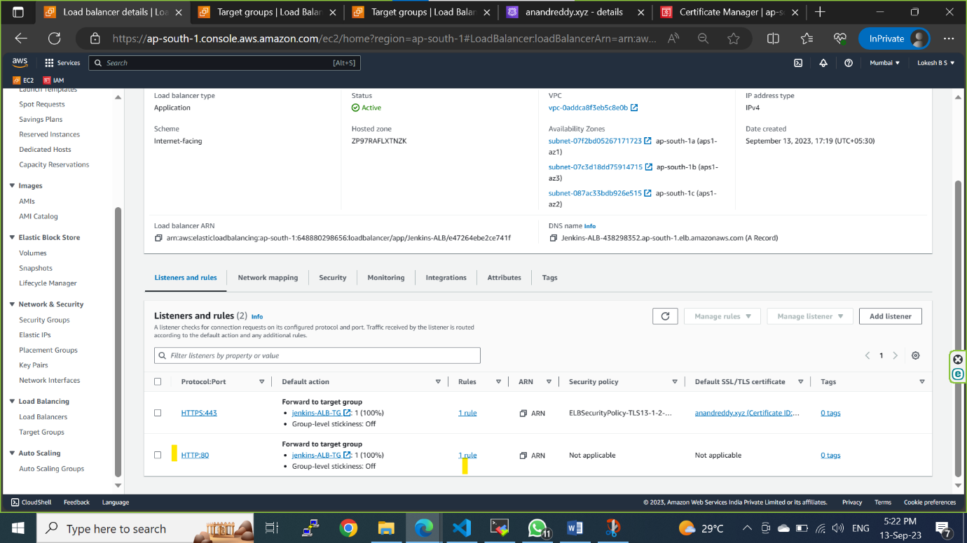

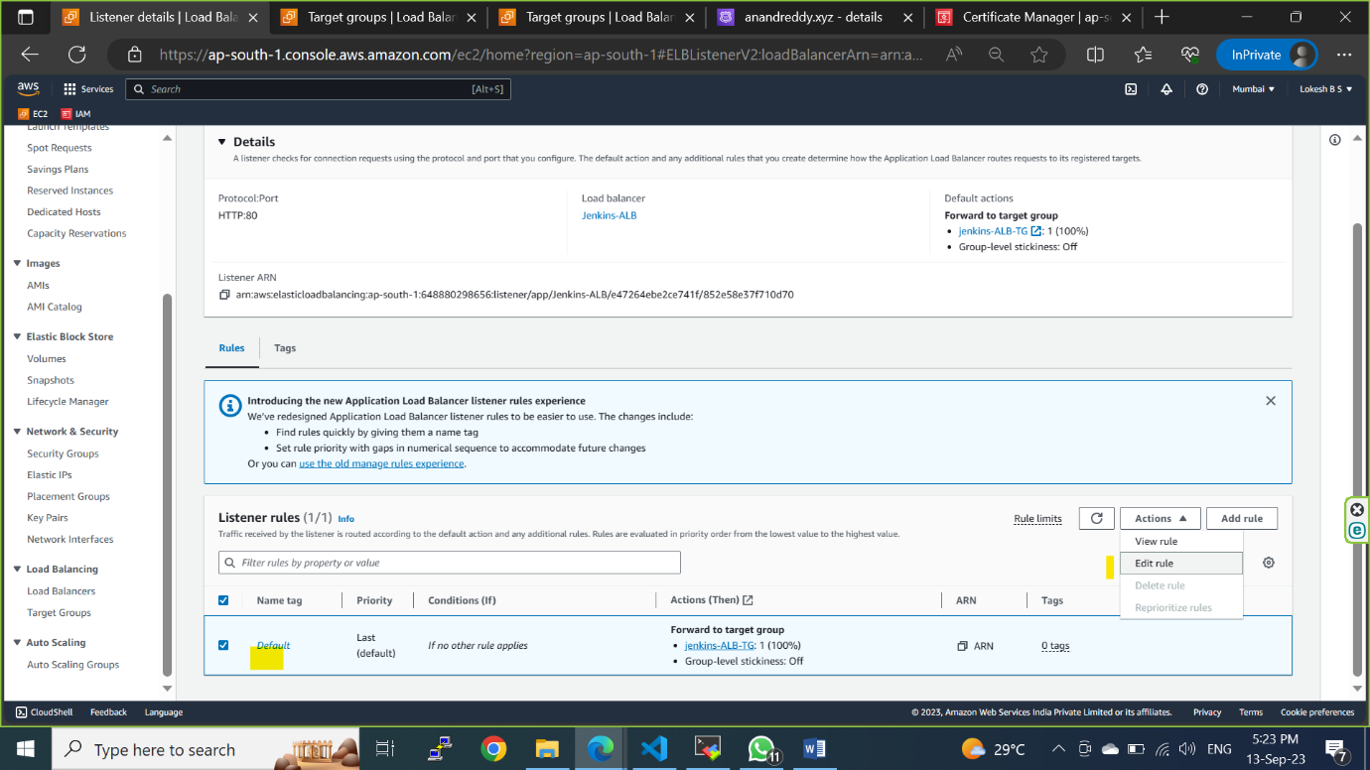

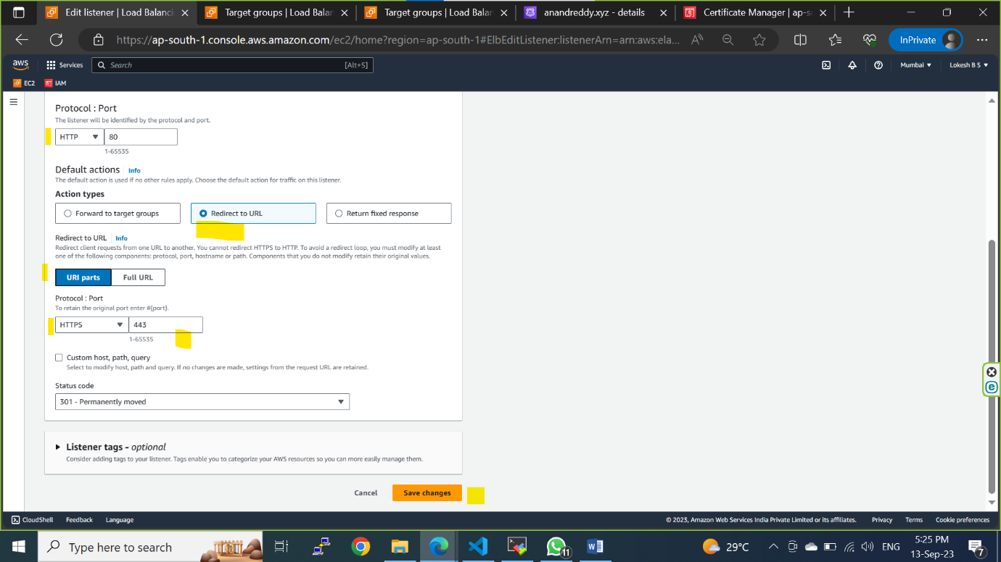

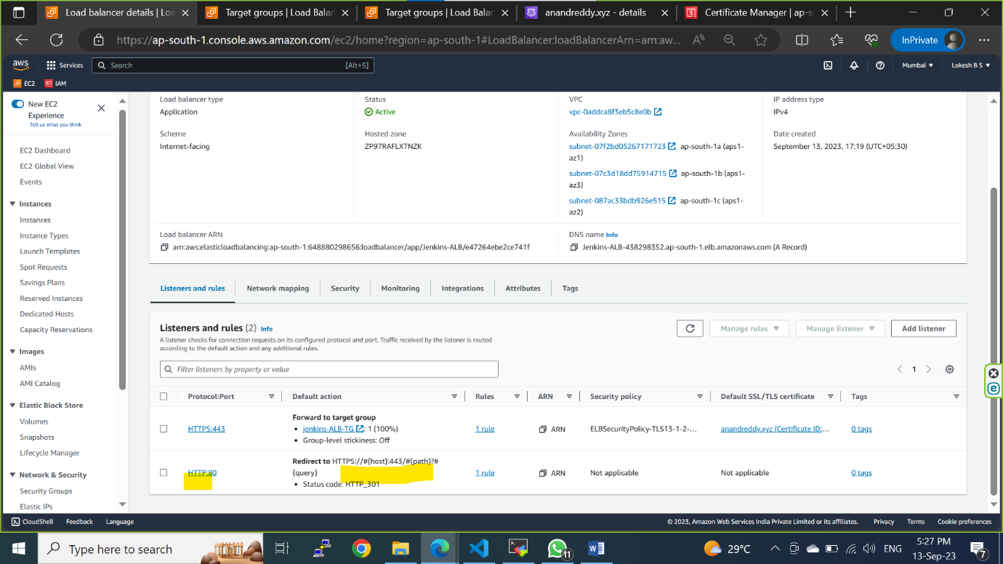

Step8: Goto Route 53 and create a Hosted Zone and add the domain name created from go-daddy website.

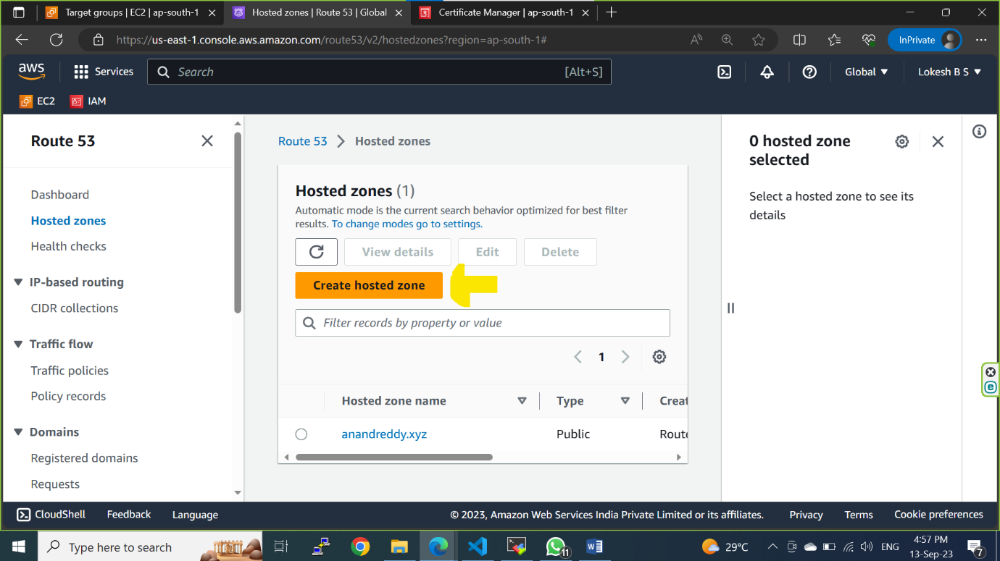

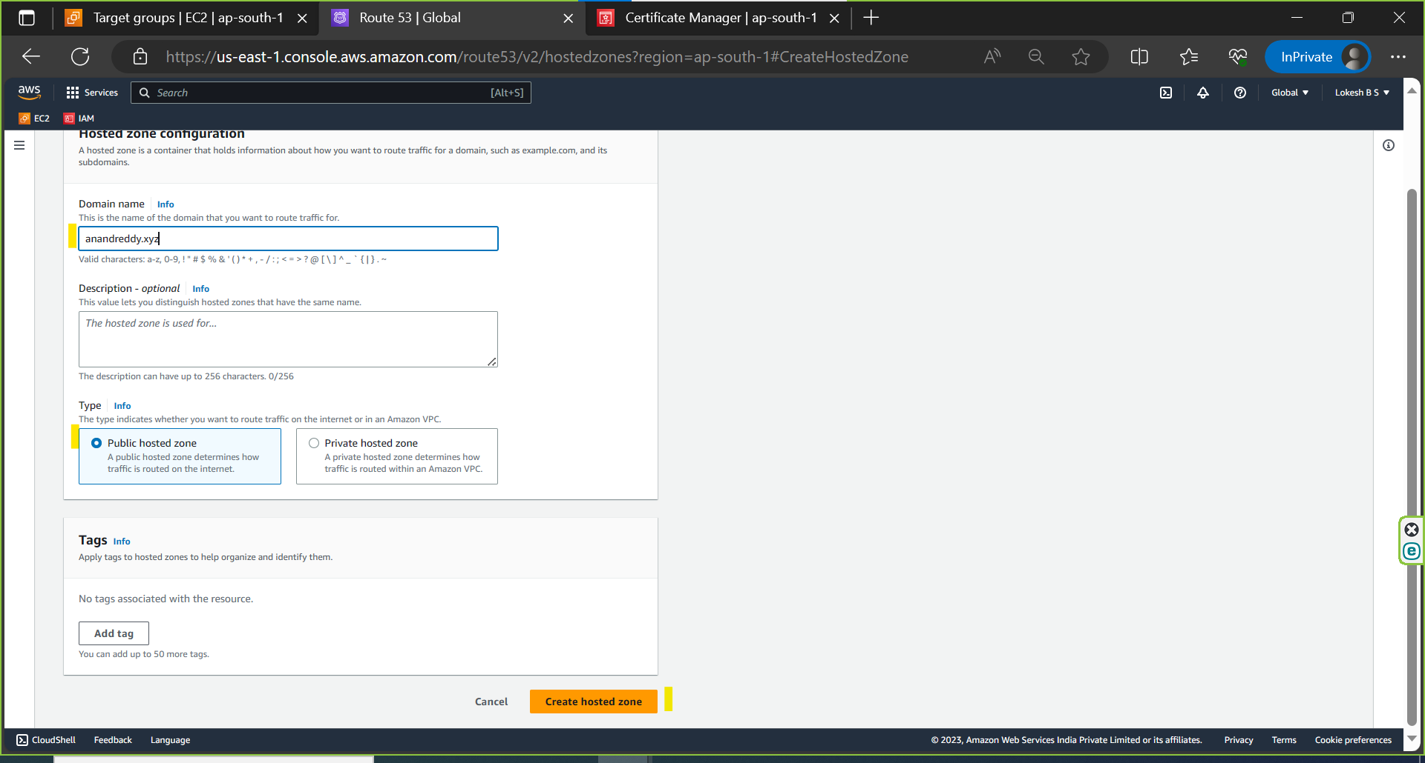

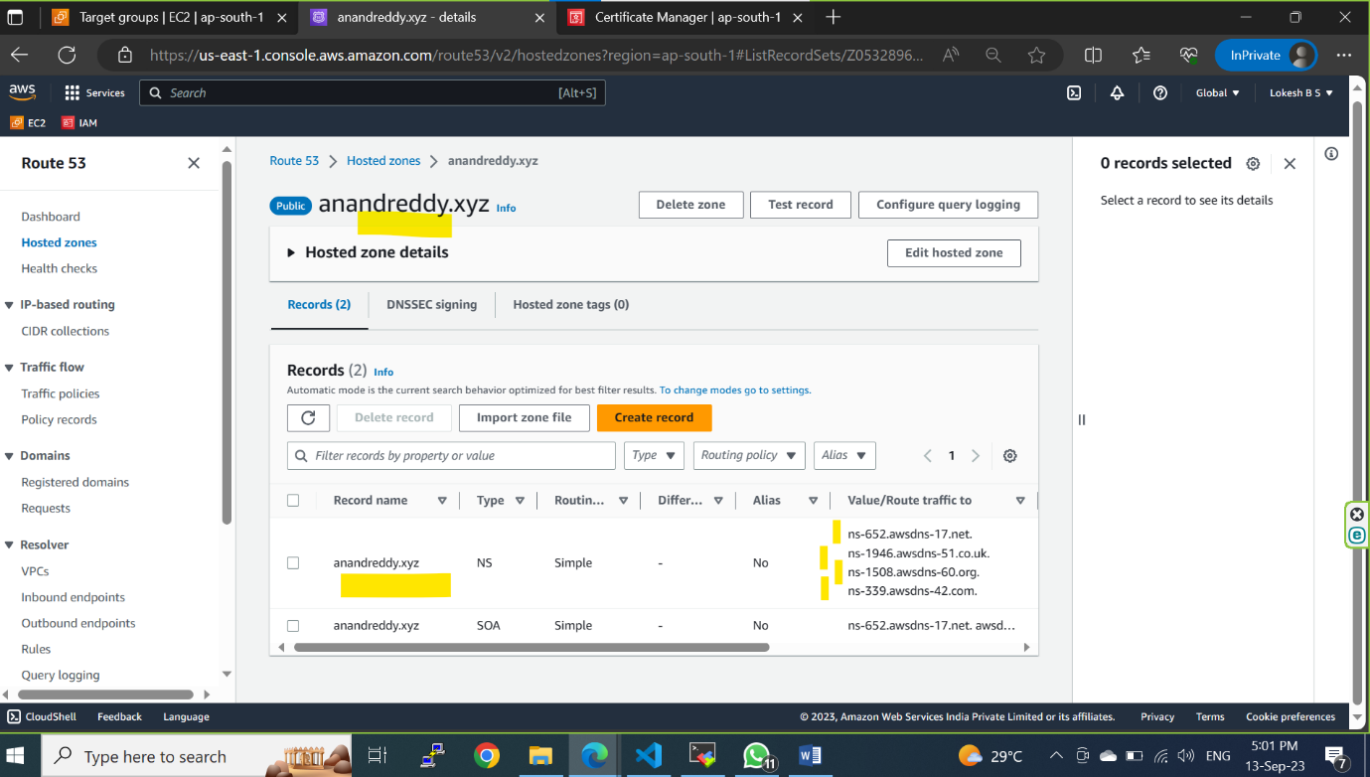

Step9: go to go-daddy wesite and add the hosted zone name servers into the domain name servers in go-daddy website.

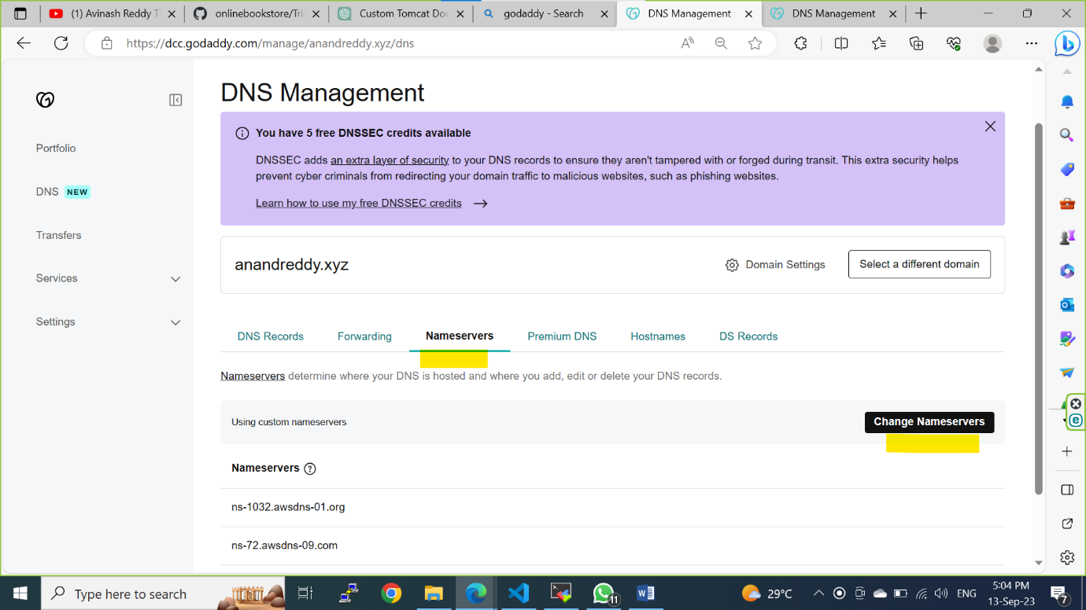

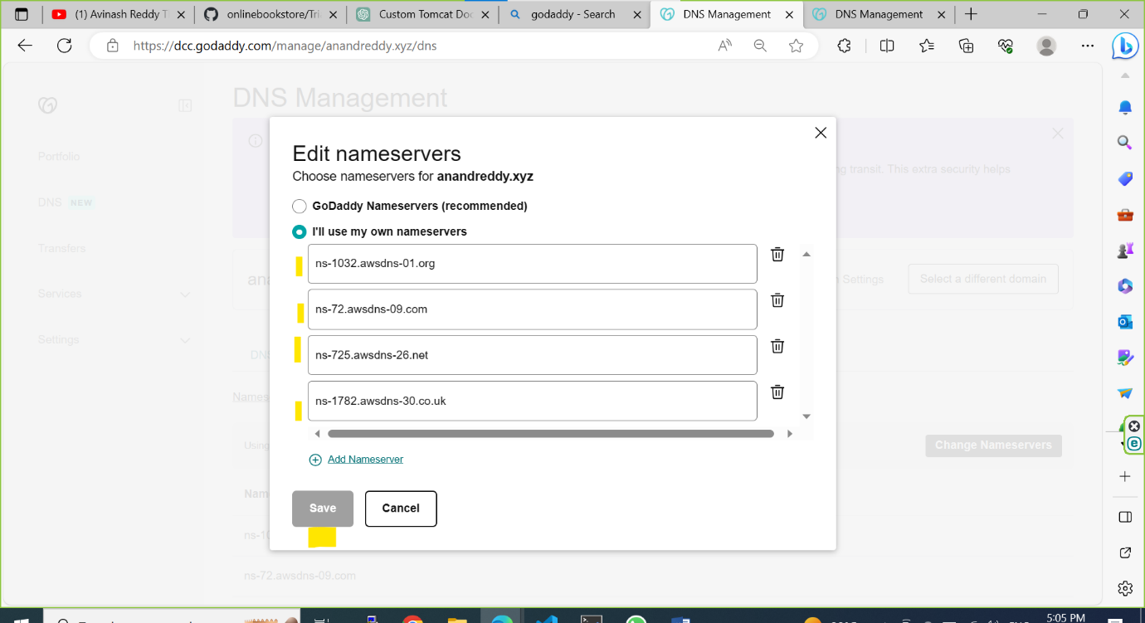

Step10: copy the loadbalancer DNS name and create a A record in Route 53

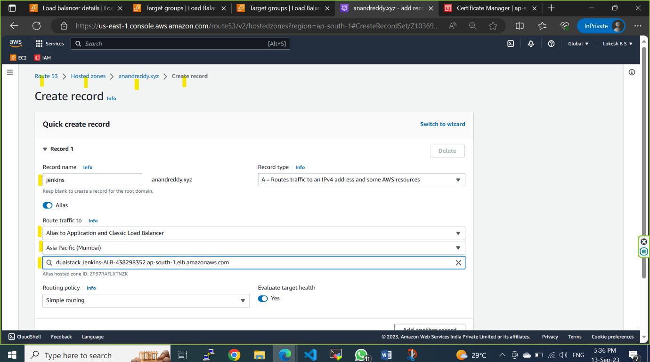

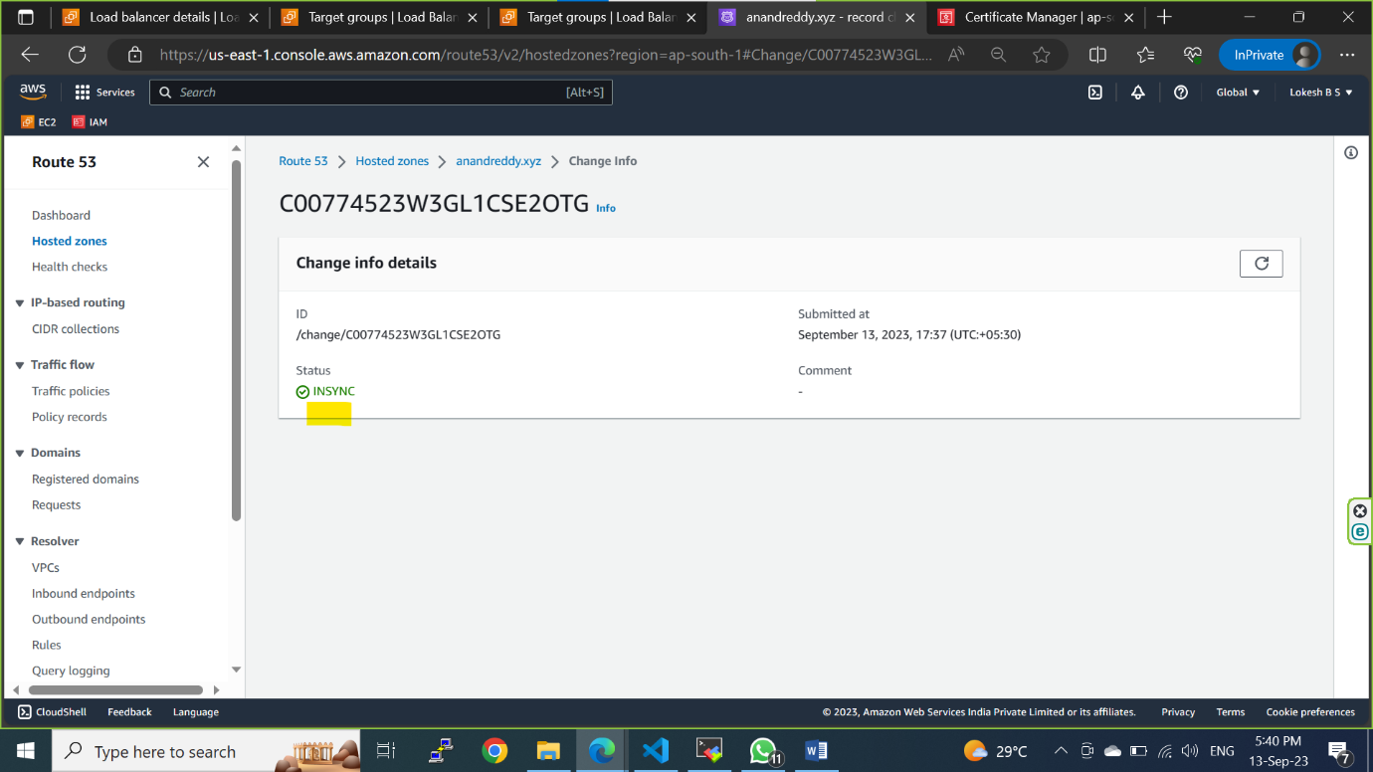

Step 11: Load balancer sending traffic to the Jenkins server successfully through HTTPS

